30 DAY RHO BILLING ENCOUNTER NOTE

Patient ID: @NAME@ is a @AGE@ @SEX@

Center for Healthy Infant Lung Development (CHILD) Clinic Recorded Home Oximetry Telemedicine Program

Dear @PCP@,

We had the pleasure of seeing your patient, @NAME@ who is part of our Recorded Home Oximetry (RHO) program. As you know, @FNAME@ is a @GAB@ @SEX@ now @CGA@ corrected age who currently has a home oxygen therapy requirement for BPD.

@FNAME@ is followed in the Center for Healthy Infant Lung Development (CHILD) Clinic at UMMMC for their supplemental oxygen requirement. Due to {HIS/HER} oxygen requirement they are a part of our RHO program. The RHO program is a telemedicine program, that aims to safely and effectively monitor and wean home oxygen therapy remotely between monthly clinic visits. As part of this program, our clinic obtains bi-weekly oximetry downloads from their home oximeter. Parents receive a call twice weekly by a member of our RHO Clinic Staff to either maintain, increase, or wean their current flow rate after my personal review and interpretation of the data. Oxygen flow rates are weaned or increased in 50% decrements or increments based off our consensus-based guideline for saturation rates below 96% and 93% SpO2.

RHO Program's Weaning Algorithm:

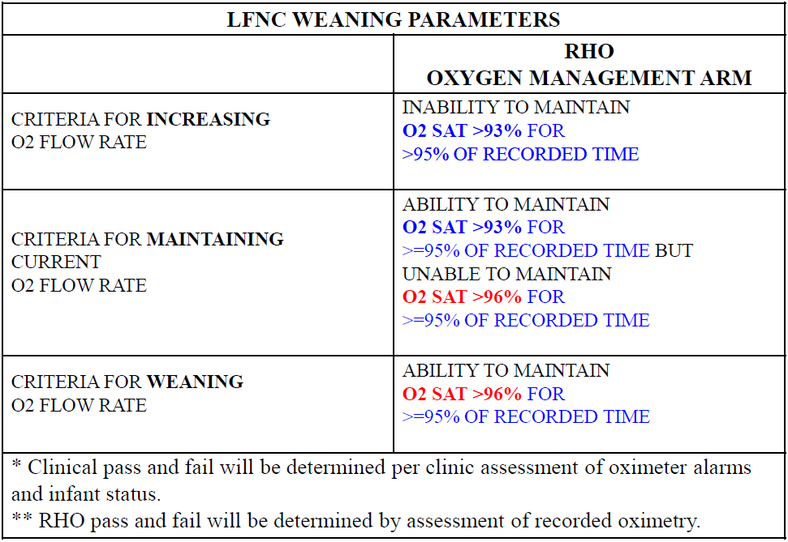

@FNAME@ is currently on {0.125/0.25/0.5/0.75/1} L/min of {continuous/nocturnal} oxygen at home. Since our visit on ***, {he/she/they} has been able to successfully {wean/increase/continue} {from/on} {0.125/0.25/0.5/0.75/1} L/min of {continuous/nocturnal} oxygen. Please see telephone encounters entered by *** for documentation of each titration made between this reviewing period. I personally reviewed and interpreted each oximetry epoch and agree with the titrations made during the billing period of *** and @TODAYDATE@.

Today's data uploaded from their home oximeter indicates that infant spent ***% of total uploaded time under 93% and ***% under 96%. @NAME@ {is/Is not} eligible to wean.

I reviewed ***'s note from @TODAYDATE@ , and I {agree/disagree} with the recommendation to { wean/increase/continue } {to/at} { 0.125/0.25/0.5/0.75/1} L/min of {continuous/nocturnal} oxygen. ***. I communicated today's results with @FNAME@'s {AMB HEM PSYCH BMT MOTHER/FATHER} who verbalized understanding.

***.

Sincerely,

@ME@

Thank you for involving us in the care of this patient. *** minutes of this *** minute encounter was spent counseling and coordinating care, specifically reviewing and interpreting recorded oximetry from @FNAME@ home monitor, reviewing home oxygen management and weaning strategies, and reviewing the patient's available data including medical history, recent events, and long-term management of their BPD.

@TODAYDATE@

