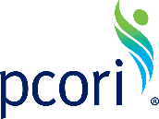
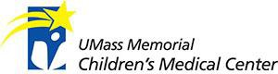
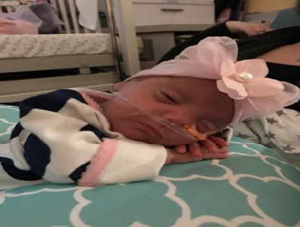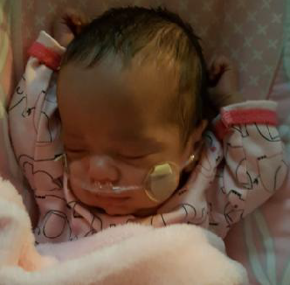
The Recorded Home Oximetry (RHO) Oxygen Weaning Program
Participating Centers in the RHO Program and RHO Implementation Trial  Arkansas Children’s Hospital, Little Rock, AR  Boston Children’s Hospital, Boston, MA  Children’s Hospital of Philadelphia, Philadelphia, PA  Cincinnati Children’s Hospital, Cincinnati, OH  Dartmouth Hitchcock Medical Center, Lebanon, NH  Maria Fareri Children’s Hospital, Valhalla, NY  Massachusetts General Hospital for Children, Boston, MA  National Jewish Health, Denver, CO  Nationwide Children’s Hospital, Columbus, OH  Peyton Manning Children’s Hospital, Indianapolis, IN  University of California Medical Center, San Diego, CA  University of Kentucky Children’s Hospital, Lexington, KY  University of Maryland Medical Center, Baltimore, MD  Vanderbilt University Medical Center, Nashville, TN | RHO Program Contact Information  <Principal Investigator Name>  <Title>  <Address>  <Email>  <Phone>  <Additional Site Contact Name>  <Title>  <Address>  <Email>  <Phone>

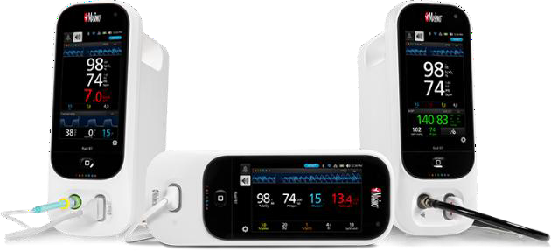 |  | About RHO  The RHO trial compared two home oxygen management strategies. The first group was randomly assigned to the standard of care group, which included monthly clinic visits to determine readiness to wean. In comparison, the study group had the same monthly clinic visits but added recorded home oximetry (RHO) to guide clinical decision making around weaning. Since infants on home oxygen may be ready to wean between monthly clinic visits, the use of RHO between clinic visits could potentially shorten time on supplemental oxygen.  The RHO trial found that utilization of RHO is a safe and effective strategy for managing home oxygen in premature infants. Infants weaned using RHO weaned from oxygen in 78 days (on average) compared to 100 days in infants managed with monthly clinic visits alone. |  | “The RHO Program gave me peace of mind that my child was doing well at home and making progress with his weaning.” -Parent of RHO Program Participant
What is the RHO Program?  The Recorded Home Oximetry (RHO) Program follows infants with bronchopulmonary dysplasia, or lung disease of prematurity on home oxygen therapy, to help them safely and effectively wean their oxygen after hospital discharge.  Your child will receive a pulse oximeter through your home care company that is WIFI-enabled. This will allow your doctors to use downloaded data twice per-week, in addition to seeing you monthly in clinic. These check-in’s will allow for earlier identification of your child’s readiness to wean the flow rate of oxygen.  Your medical team will contact you twice per- week with results of your child’s oximetry data.  They will review the results and any changes to be made to your child’s current oxygen flow rate. |  |  |  | Data Collection  The RHO Implementation Study is a multi-site research study funded by the Patient Centered Outcomes Research Institute (PCORI) with a goal of simplify home oxygen use, shortening your  child’s hospital stay, and the time spent on oxygen after discharge.  Data is being collected from your pulmonary follow-up center. Information being collected includes hospital course information, time on oxygen, and any emergency room visits or hospitalizations while weaning from oxygen.  Your child’s information w ill be deidentified and kept secure. If you are not interested in  having your child’s information shared please opt-out w ith your medic al team responsible for oxygen weaning.
Implementation of the RHO Program
The RHO Program has been helping to wean infants off home oxygen s ince 2018 at a few centers. Now, w ith improved
technology and WIFI-enabled oximeters,
the RHO Program is ready to be used across the United States, helping even more babies
and families wean from oxygen.

