Dysfunctional Voiding (Objective I.4, 1.5)
- Lower Urinary Tract Dysfunction (Objective I.4, 1.5)
  - Lower urinary tract dysfunction (LUTD) impacts up to 22% of children and includes over/under active bladder, voiding postponement, infrequent voiding, increased daytime frequency, vaginal reflux, bladder neck dysfunction, and giggle incontinence. Lower urinary tract dysfunction increases the risk of vesicoureteral reflux and urinary tract infections. With time, this may result in renal scarring and chronic kidney disease. LUTD is commonly associated with bowel dysfunction including constipation, behavioral abnormalities, and psychiatric conditions (Fuentes 2019).
  - The following flow chart illustrates the diagnostic steps of LUTD (Fuentes 2019). The Dysfunctional Voiding Symptom Survey created by Farhat et al. 2000 provides a quantitative approach to characterize the severity of LUTD (Farhat 2000).
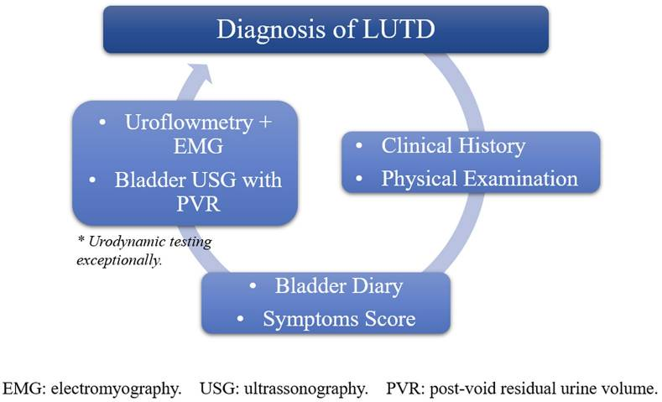
Fuentes 2019
  - The mainstay of treatment for LUTD is behavioral therapy. The focus of the therapy is timed voiding every 3 hours in the proper position, adequate fluid intake, diet with limited caffeine consumption, and correction of constipation. Second line therapy includes medications such as antimuscarinics or beta-3 agonists (Fuentes 2019).
- Bladder Bowel Dysfunction (Objective I.4, I.5)
  - Bladder bowel dysfunction (BBD) is defined by the International Children’s Continence Society as simultaneous lower urinary tract and bowel dysfunction. BBD is associated with recurring urinary tract infections, vesicoureteral reflux, and renal scarring (Yang 2018).
  - The diagnosis of BBD mirrors the evaluation of lower urinary tract dysfunction, however should include the evaluation of gastrointestinal symptoms. This can be evaluated with a bowel diary, ROME criteria, use of the Bristol stool chart, and measurement of the transverse rectal diameter via ultrasound (Yang 2018).
  - Treatment of bowel bladder dysfunction includes treating the voiding abnormalities as discussed above. Additionally, the treatment should focus on improving constipation with behavioral therapy and bowel regiments (Yang 2018).

