Nephrolithiasis (Objective I.1, I.5)
- Pediatric nephrolithiasis occurs when urine elements are supersaturated resulting in stone formation. The most common type of kidney stone in pediatrics is calcium oxalate. This classically presents with colicky abdominal pain, nausea, vomiting, irritability, and hematuria (Hernandez and Moreno 2015).
- The evaluation for pediatric nephrolithiasis should include a 24 hour urine collection to evaluate levels of calcium, oxalate, magnesium, phosphorous, sodium, potassium, and citrate. A urinalysis should be obtained for evaluation of specific gravity, urine pH, hematuria, pyuria, microscopic analysis for crystals, and culture. Additional laboratory work up consists of analysis of kidney stone material, electrolyte levels, renal function panel, parathyroid, and vitamin D. Diagnostic imaging includes a low-dose CT or renal ultrasound (Hernandez 2015).
- The treatment of acute nephrolithiasis consists of medical or surgical management. The majority of pediatric patients are managed with analgesic therapy and hydration until spontaneous stone passage is achieved. Some studies have demonstrated an increased rate of stone expulsion with Tamsulosin therapy. Surgical intervention depends on the stone size but may include shock wave lithotripsy, ureteroscopy, percutaneous nephrolithotomy, or pyelolithotomy. If the patient presents with complete ureteral obstruction, acute kidney injury, or intractable pain, then acute decompression with a ureteral stent or percutaneous nephrostomy tube is warranted (Hernandez and Moreno 2015).
- Recurring nephrolithiasis can be treated with lifestyle and medical interventions. Lifestyle modifications to prevent recurrence of kidney stones include limiting sodium, increasing fluid intake with a goal of 2 L/m²/d, consuming recommended levels of calcium, maintain adequate vitamin D levels, avoiding excessive protein consumption, increasing intake of fruits and vegetables, and discontinuing medications that contribute to kidney stone formation. Medications should be considered in patients who have recurring stones despite lifestyle modifications as recommended in the following table (Hernandez and Moreno 2015).

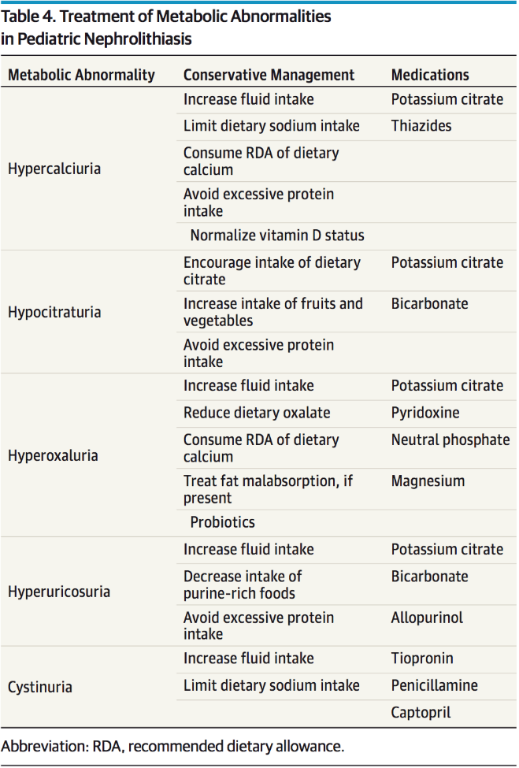
Hernandez and Moreno 2015

