Proteinuria: (Objective Id)
- Proteinuria in children ages 6 to 24 months is defined as a protein excretion of greater than 300 mg/m² over a 24-hour period as measured by a 24-hour urine collection or a urine protein creatinine ratio of >0.5 mg/mg (Viteri 2018).
- Proteinuria in children greater than 24 months is defined as a protein excretion of greater than 100 mg/m² over a 24-hour period or a urine protein creatinine ratio of >0.2 mg/mg (Viteri 2018).
- The following flow chart adapted from the AAP 2018 guidelines provides an algorithm on the evaluation of proteinuria in a primary care setting.
- The management of proteinuria should target the underlying cause, however in practice it is commonly treated with an angiotensin-converting enzyme inhibitor or angiotensin II receptor blocker or angiotensin receptor blocker (Leung 2010).

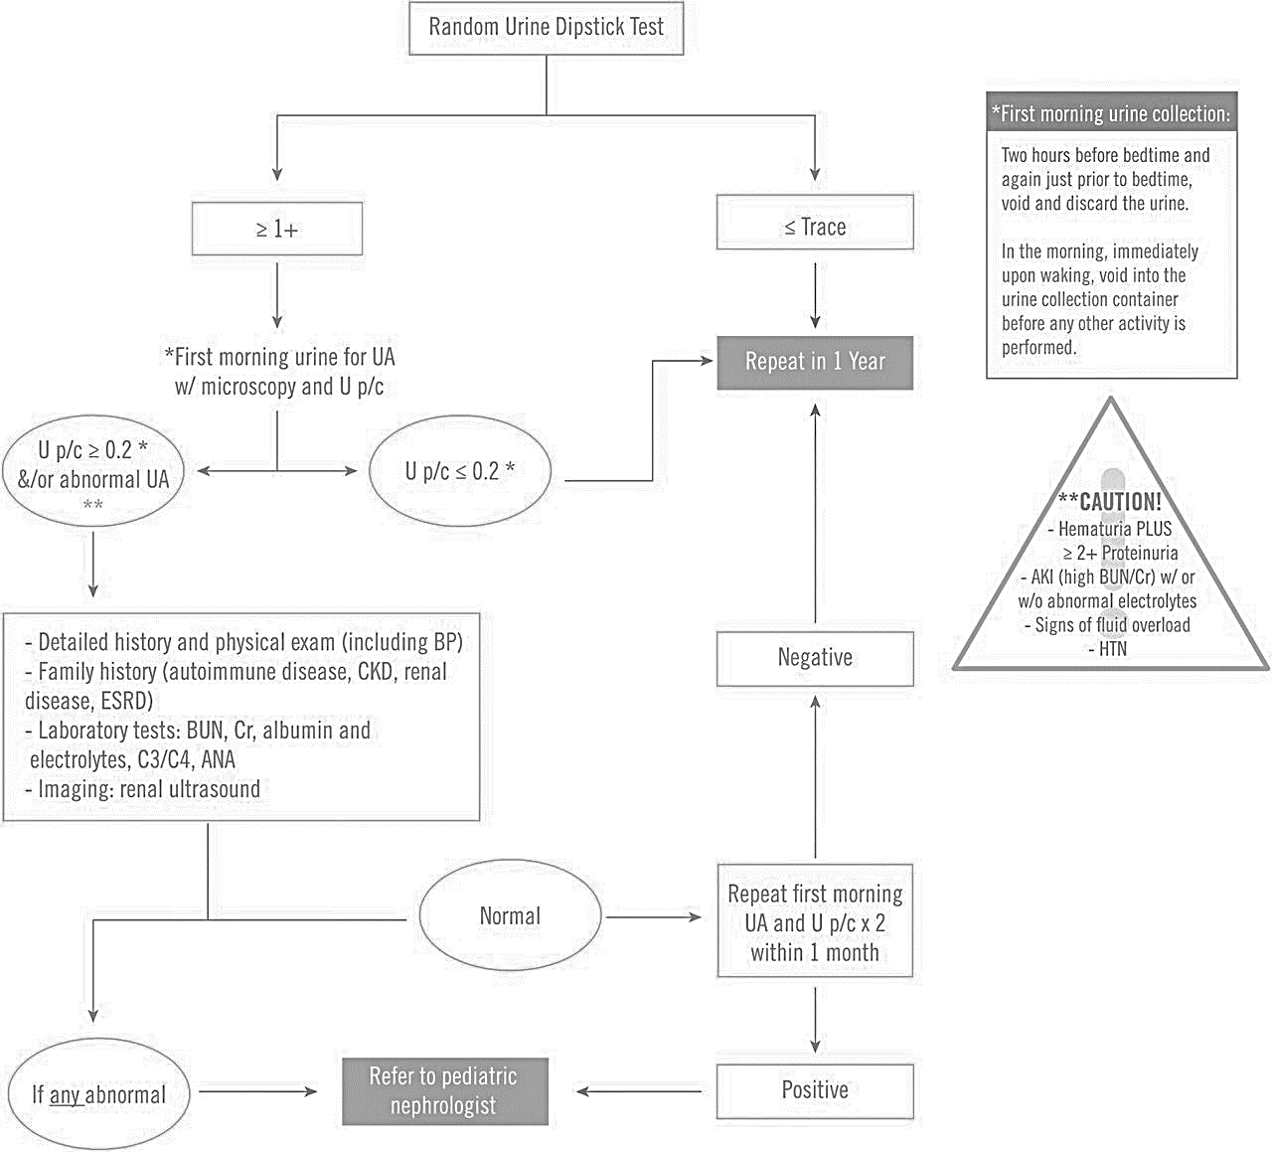
Viteri and Reid-Adam, 2018

