Disordered Eating & Eating Disorders, August 2020
PREP Self-Assessment Questions:

1. A 14-year-old adolescent is brought to your office for fatigue and decreased appetite that she has experienced over the past month. She has associated nausea but no vomiting, diarrhea, or fever. Her medical history is significant for autoimmune hypothyroidism since age 8 years, for which she takes levothyroxine daily. Physical examination reveals a temperature of 37°C, heart rate of 120 beats/min, blood pressure of 90/48 mm Hg, respiratory rate of 16 breaths/min, weight of 44.6 kg (25th percentile), height of 165 cm (75th percentile), and body mass index of 16.4 kg/m2 (10th percentile). She appears tired, with diffusely hyperpigmented skin. Capillary refill time is 3 seconds. The remainder of her physical examination findings are unremarkable.

Of the following, this girl’s MOST likely diagnosis is

A. adrenal insufficiency
B. anemia
C. anorexia nervosa
D. gastroparesis
E. uncontrolled hypothyroidism

The girl described in the vignette has Addison disease, primary adrenal insufficiency. In primary adrenal insufficiency, there is a deficiency of both glucocorticoid (cortisol) and mineralocorticoid (aldosterone). In response to low cortisol levels, adrenocorticotropic hormone (ACTH) levels are high. The girl’s diffuse hyperpigmentation is due to the high ACTH level. Her fatigue, decreased appetite, and nausea are all consistent with Addison disease. Weight loss can be another presenting symptom. Mineralocorticoid deficiency in Addison disease manifests clinically with dehydration, also exhibited by this girl. Her history of autoimmune hypothyroidism suggests an autoimmune etiology for her adrenal insufficiency. Laboratory findings consistent with primary adrenal insufficiency include hyponatremia, hyperkalemia, hypoglycemia, and metabolic acidosis. Serum cortisol concentration is low and ACTH is high. Eosinophilia may also be seen. Anemia, anorexia nervosa, gastroparesis, and uncontrolled hypothyroidism can each cause some, but not all, of the signs and symptoms described in the vignette. If adrenal insufficiency is suspected, a bedside blood glucose test should be performed, because of the high risk for hypoglycemia. Serum electrolyte, glucose, cortisol, and ACTH levels should be obtained.

2. You are seeing a 16-year-old girl in the emergency department. She was referred by her primary care provider for concerns of dehydration. Her father reports that the girl has had poor oral intake for the last 3 months, over which time she has lost 16 kg. During an interview with the girl alone, she discloses that she was very upset about her weight and placed herself on a 500 kcal/day diet 3 months ago. The girl reports that she often feels fat and bloated. She uses an over-the-counter diuretic 3 or 4 times per day. On physical examination, the girl’s body mass index is at the second percentile for age. Her heart rate is 49 beats/min and her blood pressure is 90/55 mm Hg. She has lanugo hair on her chest and marked diffuse muscle wasting.

Of the following, a diagnostic criterion for this patient’s suspected condition is

A. amenorrhea
B. excessive exercise
C. intense fear of gaining weight
D. self-induced vomiting
E. use of medication to prevent weight gain

The girl described in this vignette has anorexia nervosa (AN). Diagnostic criteria for AN, as defined by the Diagnostic and Statistical Manual of Mental Disorders (DSM)-V include: 1. Restriction of energy intake resulting in significantly low body weight 2. Intense fear of gaining weight 3. Severe body image distortion with denial of the seriousness of the illness
Amenorrhea was removed as a criterion for diagnosis in the DSM-5. There are 2 subtypes of AN: restrictive, marked by severe restriction of caloric intake, and binge-eating/purging, characterized by caloric restriction along with regular binge-eating episodes or purging behaviors such as self-induced vomiting and/or diuretic use. The differential diagnosis for AN includes medical conditions that may cause weight loss such as thyroid disease, inflammatory bowel disease, and chronic infection. However, many of these conditions can be excluded with a thorough history and physical examination. Medical complications of AN include dehydration, electrolyte disturbance, menstrual irregularities, impaired gastric motility, dysrhythmias, cardiomyopathy, and cognitive deficits. Collaborative interdisciplinary and interprofessional care is necessary for the management of AN and includes medical stabilization, nutritional rehabilitation, and psychotherapy.

3. A 14-year-old girl is in the office for a routine follow-up visit. For the past 3 months, she has been treated for anorexia nervosa by a multidisciplinary team. Overall she is doing well with treatment and has gained 4.5 kg. Her current weight is 43.2 kg and body mass index is 15.4 kg/m2 (3rd percentile). She is working hard to eat 3 balanced meals per day and limit her exercise to no more than 1 hour/day of moderate-intensity swimming. Her last menstrual period was 6 months ago. Dual-energy X-ray absorptiometry (DXA) performed as part of a comprehensive evaluation shows low bone mineral density for age. Her mother is very concerned about this result because the girl’s grandmother died of complications after a hip fracture. She asks what can be done to improve her daughter’s bone density.

Of the following, the intervention likely to be the MOST effective is

A. adequate caloric intake for continued weight gain
B. increased weight-bearing activity
C. replacement estrogen and progesterone
D. supplemental calcium and vitamin D

The girl in the vignette has low bone density associated with anorexia nervosa. Malnutrition, low body mass index, and estrogen deficiency are contributing factors. The intervention likely to be the most effective in improving her bone density is adequate caloric intake for continued weight gain. Weight-bearing activity, adequate estrogen, calcium, and vitamin D are important for bone density. However, increasing weight-bearing activity, providing estrogen and progesterone replacement, and supplementing calcium and vitamin D will not have significant effect without adequate caloric intake. Achieving normal weight with restoration of normal menstrual cycles will restore normal estrogen levels.In healthy children and adolescents, recommendations for optimization of bone health include adequate intake of calcium and vitamin D, weight-bearing exercise, and avoidance of smoking. The recommended dietary allowance (RDA) of calcium is 1,000 mg/day for 4- to 8-year-old children and 1,300 mg/day for 9- to 18-year-old children. Dietary sources of calcium, such as milk and other dairy products, are preferred over supplements. Other sources of calcium include green leafy vegetables and fortified cereals. Sunlight exposure is a major source of vitamin D. The RDA of vitamin D is 600 international units daily for children older than 1 year. Dietary sources of vitamin D include fatty fish (eg, salmon, tuna) and fortified foods (eg, milk, dairy products). Vitamin D supplementation is recommended for children and adolescents who do not have adequate dietary intake of vitamin D. The mechanical loading on bone during weight-bearing exercise stimulates bone remodeling and formation. Activities such as running, jumping, and dancing provide greater weight-bearing than swimming or bicycle riding. The benefits of high-impact weight-bearing exercise, however, should be weighed against the increased fracture risk with excessive high-impact activities. Furthermore, when female athletes become amenorrheic, exercise does not have the same beneficial effect on bone density.

4. A 17-year-old adolescent girl with anorexia nervosa is admitted to the hospital for inpatient psychiatric support and placement of nasogastric feeding tube. She has had persistent weight loss, restrictive eating behaviors, and laxative abuse, despite maximizing outpatient therapy. She describes frequent nausea and daily episodes of nonbilious nonbloody emesis. Over the last 6 months, she has lost 11 kg, and her body weight at the time of admission is 38 kg (body mass index, 14.1 kg/m2). She reports that she eats small amounts of food once or twice daily. Her last menstrual period was 6 months ago.

Laboratory data are shown. Of the following, the intervention MOST indicated in this patient is:

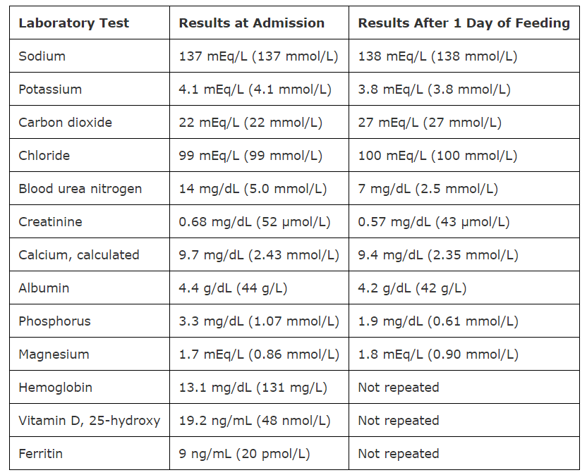

A. intravenous iron sucrose
B. intravenous potassium
C. oral magnesium
D. oral phosphate

The adolescent girl in this vignette has refeeding syndrome, as evidenced by metabolic changes following enteral nutrition supplementation via a nasogastric feeding tube. She is hypophosphatemic and requires oral phosphate therapy to avoid complications of hypophosphatemia. Underlying medical conditions resulting in increased risk for refeeding syndrome during nutritional rehabilitation include psychiatric diseases (anorexia nervosa, alcohol or drug use), failure to thrive, gastrointestinal diseases (inflammatory bowel disease, short gut syndrome, cystic fibrosis), and social risk factors (neglect, homelessness). Thus, patients at high risk for refeeding syndrome should be carefully monitored as nutritional therapy is administered. During starvation or malnutrition, fat and proteins are broken down, allowing gluconeogenesis to occur. Insulin levels are low, and already depleted levels of electrolytes shift to maintain homeostasis. Once refeeding occurs, hyperglycemia results (caused by low insulin levels) and osmolar shifts occur. Intracellular shifts of magnesium and potassium occur, resulting in hypomagnesemia and hypokalemia. Hypophosphatemia occurs due to increased utilization of phosphate for production of ATP. Increased metabolic thiamine requirements result in thiamine deficiency.
Hypophosphatemia, the most common complication of refeeding syndrome, can result in cardiac arrhythmia, respiratory failure, weakness, hemolysis, and mental status changes. Hypokalemia and hypomagnesemia can cause cardiac arrhythmia, respiratory failure, wEeakness, nausea, vomiting, changes in stool pattern, and neurologic symptoms. To avoid sequelae of refeeding syndrome, nutritional supplementation is slowly advanced over several days before achieving goal caloric supplementation. In addition, careful monitoring for refeeding syndrome should occur, including continuous cardiac monitoring, daily neurologic and cardiac examinations, calorie counts, daily weights, and baseline/daily laboratory studies including phosphorus, magnesium, potassium, sodium, glucose, and renal function. Replacement of vitamins and minerals (thiamine supplementation and multivitamin administration) should occur, and electrolyte disorders should be corrected. Intravenous iron sucrose is not indicated because the hemoglobin of the patient in this vignette is within normal limits. Intravenous potassium is not indicated as the potassium levels are within the normal range. Oral magnesium is not indicated as the magnesium level is within normal limits.

