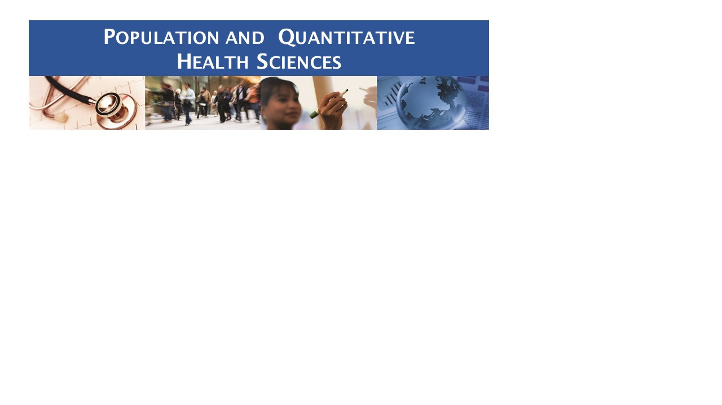

**SPECIAL SEMINAR**

**February 19th**

**12:00 – 1:00**

**AS9-2072**

**"Can Primary Care Really Influence Emergency Department Use?"**

**Presented by: Lisa Lines, PhD**

Lisa M. Lines, PhD (UMMS ‘14), MPH (UMass ‘08) is a health services researcher, currently serving as a project director in the Center for Advanced Methods Development at RTI International. She is also a voluntary instructor in Quantitative Health Sciences at University of Massachusetts Medical School. Dr. Lines’ research focuses on health services utilization, costs, quality of care, and care experiences; person-centered care; health equity; and innovative care delivery and payment models. She has presented and published in multiple clinical disciplines and settings, including oncology, neurology, nephrology, ophthalmology, mental health/substance use, primary care, emergency care, and post-acute care. As a member of the Medical Care Editorial Board, she co-founded [The Medical Care Blog](https://urldefense.proofpoint.com/v2/url?u=http-3A__www.themedicalcareblog.com_&d=DwMFAg&c=WJBj9sUF1mbpVIAf3biu3CPHX4MeRjY_w4DerPlOmhQ&r=OIo7bI6rwcfDP4kTBbvZzeUaTJt13cMieCFxHWwe-b0&m=l3LIdO6n3-WDc5_Q-j1FFK5EKhjB9dGz1Tn6RVe3n0I&s=1U-T1li1SVqkzFpmYDNqun9aLMjA2kNfnl8RqjVBO5U&e=) in 2014 and currently serves as co-editor and contributor.

About half of emergency department (ED) visits are considered to be primary care sensitive (PCS) – meaning that improved supply, quality, and accessibility of primary care should be able to reduce their number. Indeed, to the extent that PCS ED is a symptom of access problems, reducing PCS ED use might be a reasonable performance measure for primary care providers (PCPs). Patient-centered medical home demonstrations and capitated, integrated delivery models have had some success in reducing ED use, but it is not clear whether PCPs can influence PCS ED use in other contexts. This talk will synthesize results from 5 research projects that use different data sources to examine relationships between primary care and PCS ED use. We will also introduce our approach to using an algorithm to classify PCS ED use and discuss ideas for future research in this area.

**Lunch will be provided, please RSVP to Sandra Manning at** [**Sandra.manning@umassmed.edu**](mailto:Sandra.manning@umassmed.edu)